Teaching & mentoring students from Enactus Malaysia
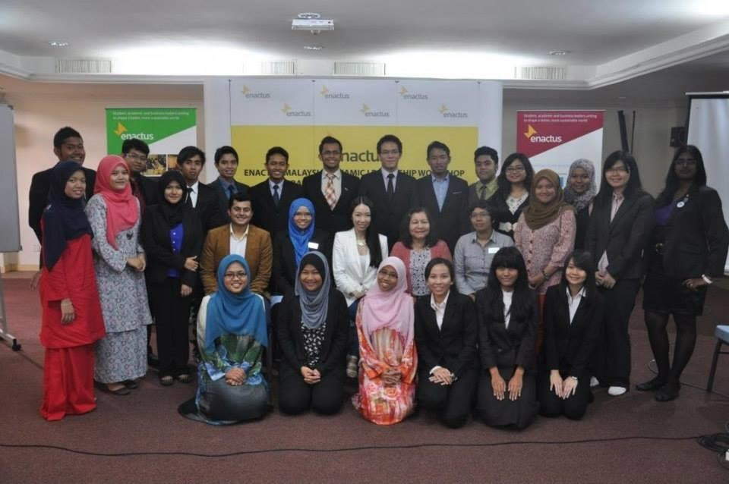
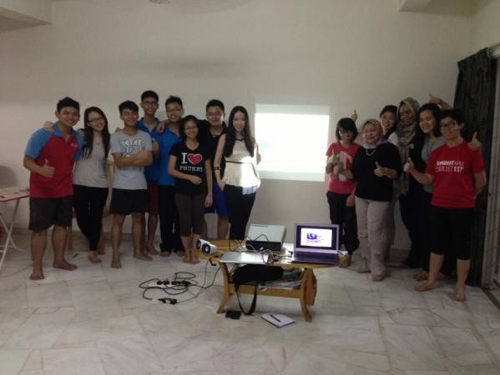
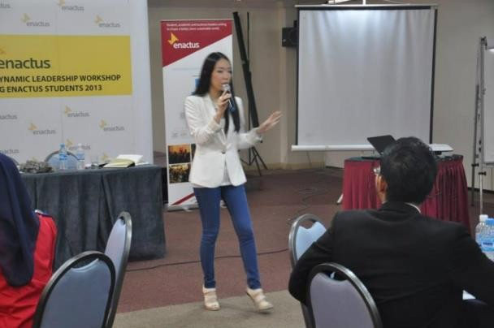
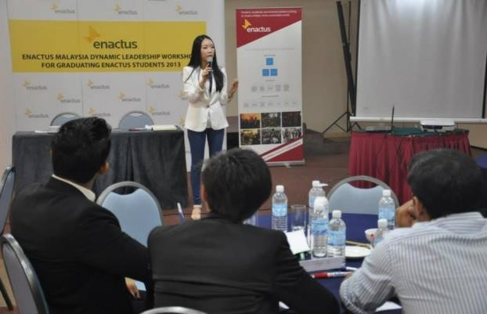
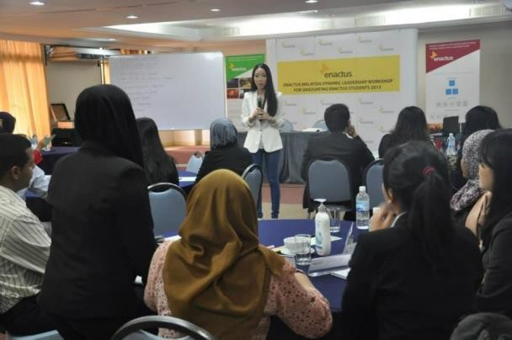

Mi-Ki was one of the judges at the press conference prior to Enactus World Cup 2013 together with other judges from Enactus Malaysia Foundation, KPMG, DRB Hicom, etc. Malaysia is represented by University Malaysia Sabah. Their royal patron is the Raja Muda of Negeri Sembilan, Tunku Ali Redhauddin Muhriz.
