Ambassadorship

Harper’s Bazaar, December 2005

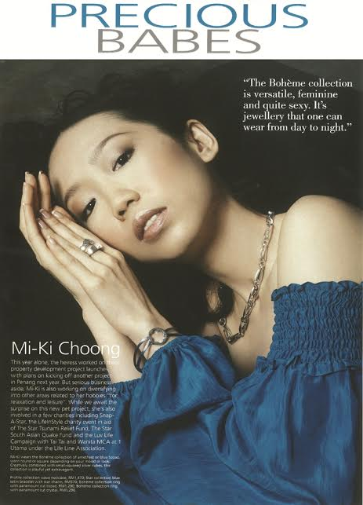

Loreal Kerastase Campaign

